1 Hour
I tink writing the program went well
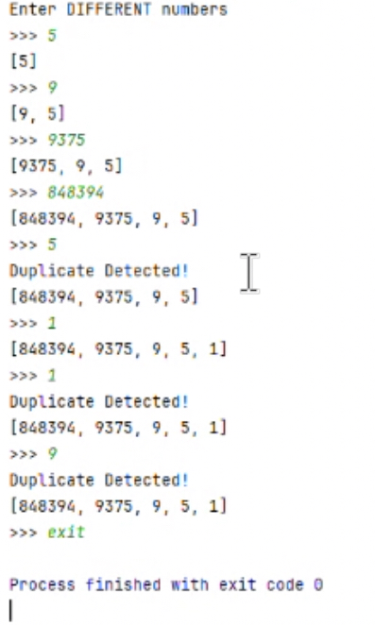
output:

